**LetsUpgrade DAY4 Assignment**

**--vemulaavinash666@gmail.com**

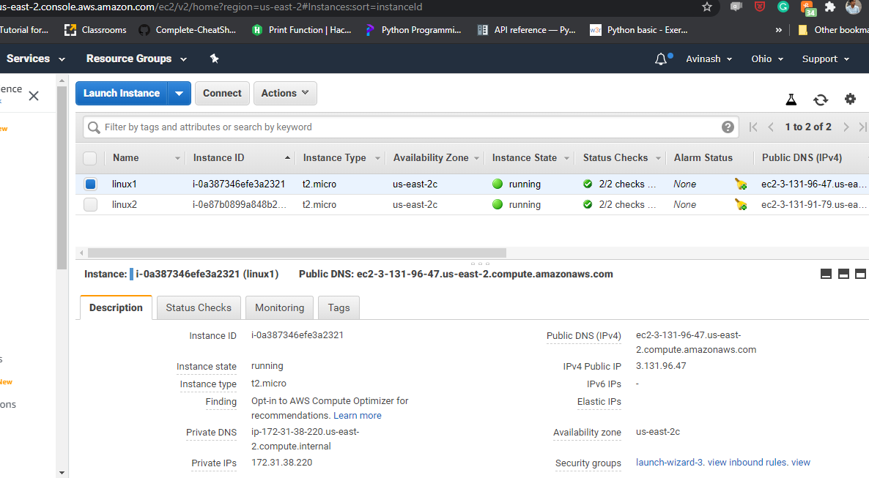

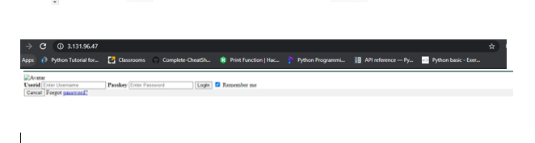

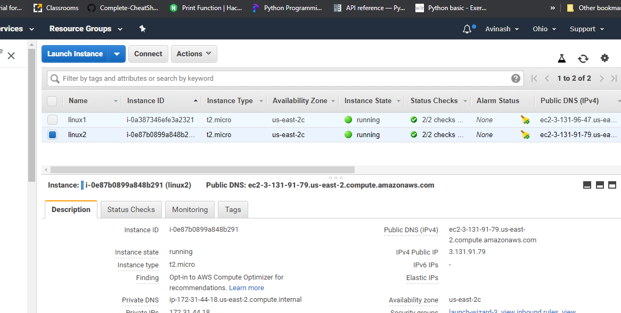

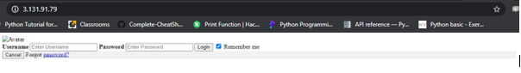

AvinashELB-925359963.us-east-2.elb.amazonaws.com